**Project** **Design** **Phase-II**

**Technology** **Stack** **(Architecture** **&** **Stack)**

|  |  |
| --- | --- |
| Date | 15 October 2022 |
| Team ID | PNT2022TMID03448 |
| Project Name | Nutrition Assistant Application |
| Maximum Marks | 4 Marks |

**Technical** **Architecture:**

The Deliverable shall include the architectural diagram as below and the information as per the table1 & table 2

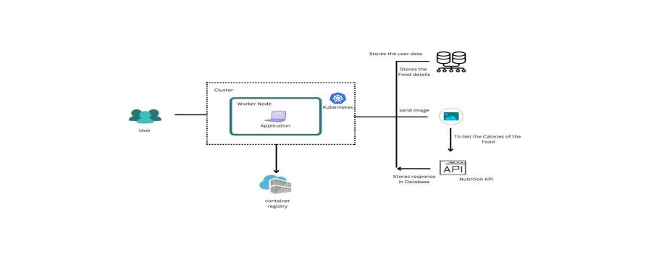

**Table-1:** **Components** **&** **Technologies:**

|  |  |  |  |
| --- | --- | --- | --- |
| **S.NO** | **Component** | **Description** | **Technology** |
| 1. | User Interface | Web UI | HTML, CSS, JavaScript |
| 2. | To get the food nutrition and calorie value | The user will upload the food picture.  Then the user will see the food nutrition value the process will compute | Python, Flask (web Framework), HTML, CSS, JavaScript. |
| 3. | Database | Get the user’s name, mail and stores the food calories value. Data type s: integer, string,  Float Number and etc., | MySQL or PostgreSQL |
| 4. | Cloud Deployment | Through is the application Will compose to the internet | Kubernetes, Docker |
| 5. | External API- 1 | To predict the image that user will upload in the upload image page | Clarifai’s AI-driven Food detection Model API |
| 6. | External API-2 | Food API’s for to the nutritional value for the identified food | Food API |
| 7. | Infrastructure (Server / Cloud) | Application Deployment on Local System / Cloud  Local Server Configuration:  Cloud Server Configuration: | Local, Cloud Foundry, Kubernetes, etc.  Docker. |

**Table-2:** **Application** **Characteristics:**

|  |  |  |  |
| --- | --- | --- | --- |
| **S.NO** | **Characteristics** | **Description** | **Technology** |
| 1. | Open-Source Frameworks | We are using both front and back end here to runs the web application. | Flask (Microweb framework) Vue.js |
| 2. | Security Implementations | List all the security / access controls implemented, use of firewalls etc. | e.g., SHA-256, Encryptions, IAM Controls, OWASP etc. |
| 3. | Scalable Architecture | Justify the scalability of architecture (3 – tier, Micro-services) | Presentation tier- HTML/ CSS/ JavaScript  Application tier- Python (API)  Data tier- MySQL, PostgreSQL |
| 4. | Availability | Justify the availability of application (e.g., use of load balancers, distributed servers etc.) | Working to reduce the severity and  likelihood of problems, closely monitoring applications and  infrastructure, keeping technical  debt in check, automating  recovering mechanisms, and  regularly putting those recovery mechanisms to the test. |
| 5. | Performance | Design consideration for the performance of the application (number of requests per sec, use of Cache, use of CDN’s) etc. | Optimize image sizes, use a content delivery network, use  website caching and adopt cloud based website monitoring. |